Chicken Wing Dissection

Subject:  Related Subjects: | Grade Level(s):  Length of Lesson: | Type: Inquiry / Design / Project  Keywords:

Lesson Overview
Observe the muscles, bones, and blood vessels that make up a bird’s wing.

Lesson Focus
What is the central question or phenomenon being investigated? What problem are they trying to solve?

Lesson Objective(s) | For today’s lesson plan, students will be following along visually with a chicken wing dissection and taking detailed notes regarding their observations and findings.The advantages of having students carry out dissection include:  - Greater appreciation of the inner workings of the body.  - Greater understanding of life and death.  - First-hand understanding of anatomical variability.  - Improved teamwork skills.

Lesson Timing

5 minutes | Introduce the Lesson
30 minutes | ...

Materials | - protective gloves  - scissors  - sharp knife  - chicken wing  - safety goggles
Instructor Prep | - Step 1
Related Resources | - List related lessons/ppts etc available from USC or outside, trusted orgs

Lesson Plan

Introduction
Dissection has been used for centuries to explore the anatomy of animals and plants. The amount we've learnt about biology from this practice is unparalleled and remains a practice in the modern world; from postmortems to classroom dissection, there's no better way of learning what's under the skin of an organism.Today, while still controversial in many parts of the world, dissection is considered a standard practice in the fields of pathology and forensic medicine.

Procedure
1. Study the diagram of a chicken wing. Use the diagram to help you locate certain muscular
and skeletal structures.
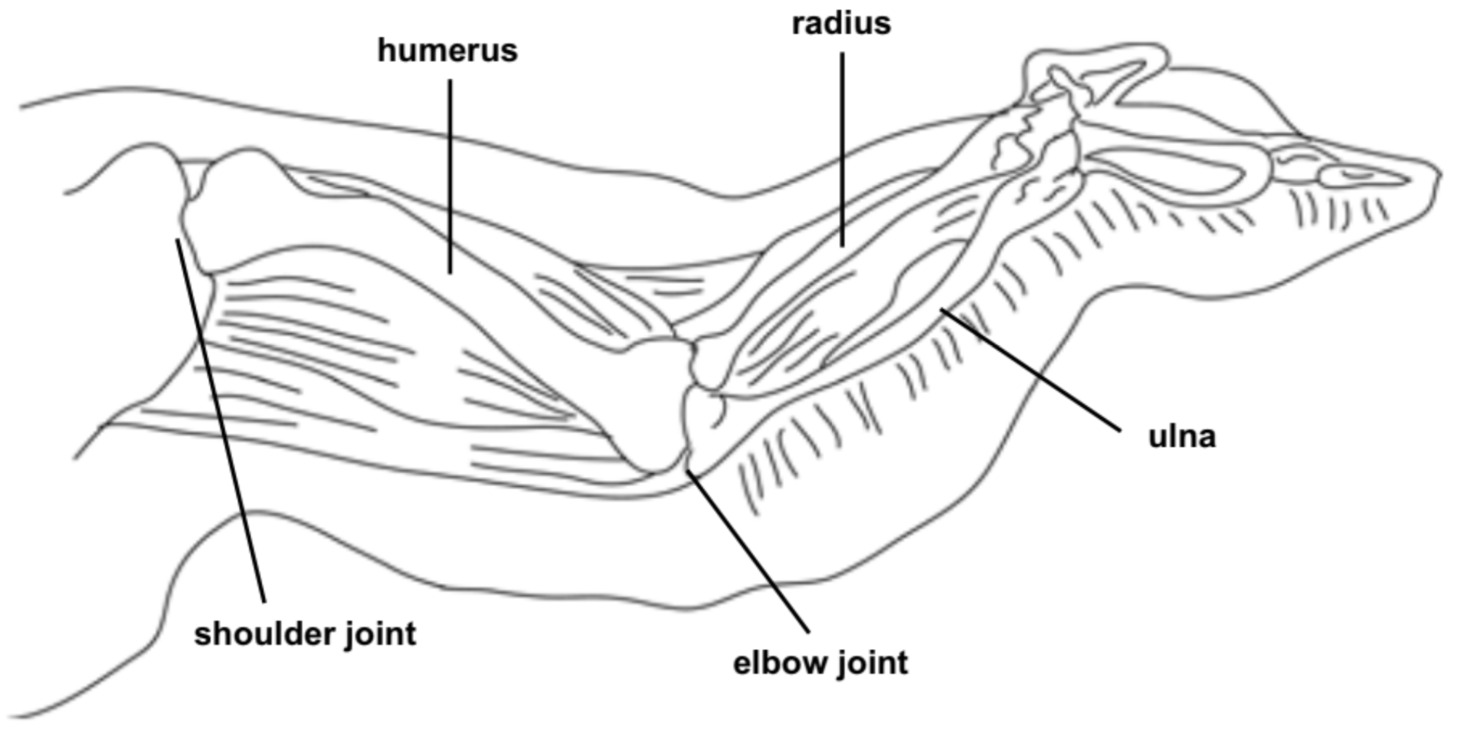
2. Rinse the chicken wing under cool, running water. Dry it thoroughly with a paper towel.
3. Examine the wing at the point where it was removed from the body. Depending on the
way the wing is cut, you might see cartilage and bone marrow.
4. Using the scissors, cut down the middle of the skin, starting at the top end of the upper
wing. Try not to cut through the muscles below the skin. Do this by piercing the skin and
then slipping the scissors between the skin layer and the muscle. Cut until you reach
the shoulder joint. (See Figure 1, Cut 1.)

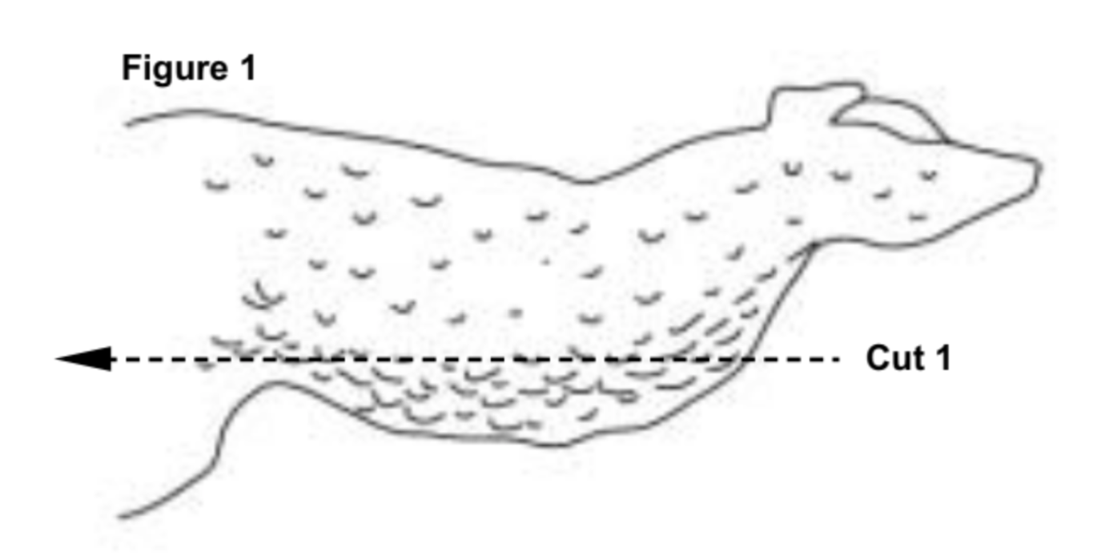
5. Cut down the sides of the skin to make a T-shaped cut. Start at the fi rst cut and cut away
from it in both directions. Peel the skin and cut to loosen it. (Note: the chicken skin can be very
diffi cult to remove. Take your time peeling it back so as not to damage the tissues underlying it.
(See Figure 2, Cut 2.)
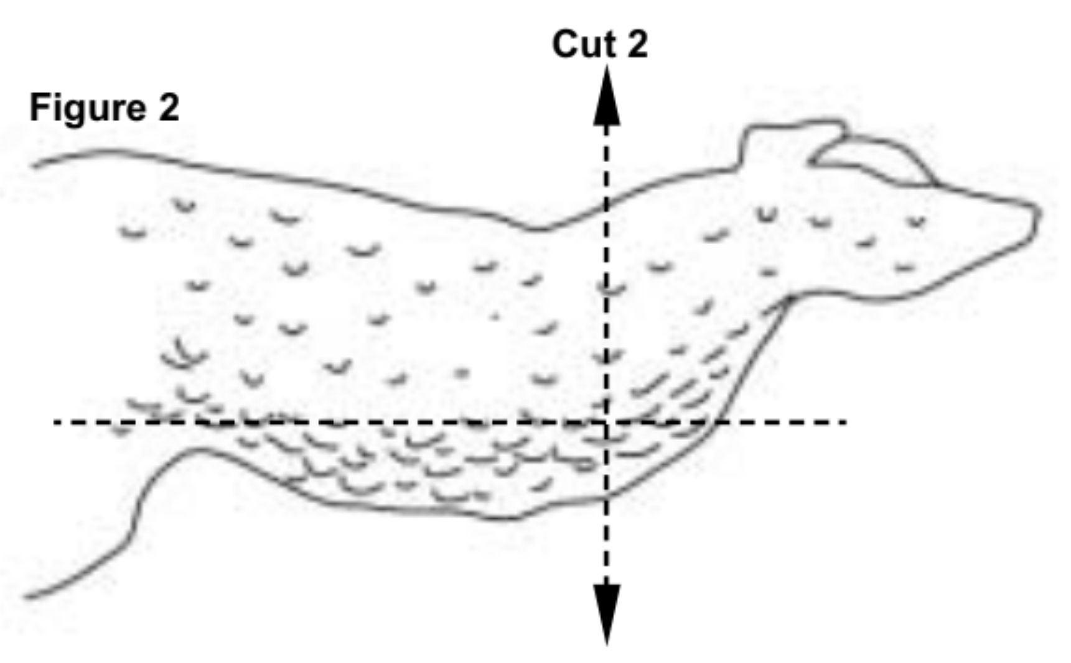
Fat
6. Look for yellowish tissue clumped together beneath the skin. This is fat tissue, made
of fat cells.
Muscles
7. Observe the muscles in the wing. They look like bundles of pale pink tissue.
8. Find two muscles in the wing that bend and straighten the elbow joint. Each muscle pulls on the
lower wing bones in one direction (the fl exor bends the joint). Since the fl exor cannot lengthen
by itself to push the bone back to straighten the joint, another muscle pulls the bone in the
opposite direction (extensor).
9. Hold the wing down at the shoulder and alternately pull on each muscle. Observe
what happens.
Tendons
10. Tendons are shiny white tissues at the ends of the muscles that attach muscles to bones.
Find as many tendons as you can on the chicken wing.
11. Pull on a tendon to see how it helps the chicken move its wing.
Joints and Ligaments
12. Two bones come together at a joint. Bend and straighten the elbow joint and observe how the
bones fit together.
13. Ligaments connect bones to other bones at joints. They look like a shiny white covering
of the joint surfaces.
14. Closely examine the elbow joint between the upper wing and the lower wing and identify
the ligaments.
Cartilage
15. Between the bones is another shiny white material that is slippery. This is cartilage,
which helps the bones move without grinding against one another, or without causing trauma.
Wing
16. Move the wing again. Explore how the muscles, tendons, ligaments, and cartilage play
roles in the wing’s movement.
17. Complete the Observation Table. When you have finished observing the wing and writing
your notes, throw the chicken remains away. Wash all equipment in hot, soapy water.
18. Wash your hands with hot water and soap.

Wrap-up
Complete the Observation Table and questions.

Tissue | Description (color, texture, etc.) | Tissue it attaches to:
Skin
Fat
Muscle
Tendon
Ligament
Cartilage

1. Do you think this wing is from the left side or the right side of the chicken’s body? Explain your answer.
2. Which joint in the human body is similar to the joint you studied?
3. Describe any interesting observations you made about the chicken wing. Include names of bones and tissues in your description when possible.

Analysis

1. What type of tissue actually moves the chicken wing?
2. Why are tendons important to a muscle’s ability to make the body move?
3. What tissue of the chicken wing is commonly referred to as the “meat”?

Conclusion
1. Based on your observations, explain the roles of muscles, tendons, bones, and joints in the
back-and-forth movement of the lower chicken wing.

Lesson Background for Teachers

Suggested Real-World STEM Connections
- List possible related Role Models in STEM (with details and links to more reading). Give suggestions for examples of scientists/engineers who are from underrepresented groups in STEM in related careers.
- List related real-world engineering problems and examples

Lesson Variations and Options
Include descriptions of alternative methods or ways to present things.

Explanation
Describe the background concepts and explanations behind the lesson. This can be more in depth than a teacher/instructor would actually share with students.

Key Concepts and Vocabulary
- Word 1: Grade Appropriate Definition
- Word 2: Grade Appropriate Definition

Safety Notes
- Safety instruction

